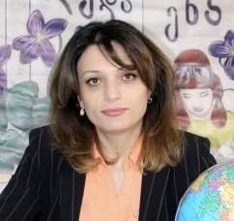 |  | EDUCATION
Public school
English as a Foreign Language Teacher
Georgia
Sep 2012- Current

Certificates

- Driving Licence Category B auto
- Professional certified (I have the relevant certificates of knowledge and skills required for professional activity.)
Julieta Nikoladze  English Teacher  summary  Creative English teacher with 12+ years of demonstrated experience achieving positive outcomes for pupils. Creates engaging lessons to produce excellent course results. Motivates and supports students with exemplary pastoral care.  CONTACT  PHONE NUMBER:  +995599901487  Georgia:  Tbilisi  EMAIL ADDRESS:  julietanikoladze@gmail.com  nikoladze.julieta@teachers.gov.ge  Previous employer’s contact information  Khashuri  Ali public school  Ali@mes.gov.ge |  | WORK EXPERIENCE
- Planned, created and delivered English subjects based on needs and interests of students.
- Participated in regular teacher training to keep updated on best teaching practices, English topic developments and school policies.
- Developed creative, balanced and relevant curriculum to boost skills and understanding of texts.
- Supported progress and development of students through ongoing motivation and assessments.
- Encouraged learning through diverse activities, providing students with opportunities to achieve their individual potential.
- Taught basic English skills to students, including reading, writing, speaking, spelling and grammar.
- Communicated effectively with parents as appropriate regarding child progress, behaviour and other reports
 |  | SKILLS
- Communication
- Creativity
- Organization
- Leadership
- Behaviour management
- Class behaviour management
- Conflict resolution and Confidence
- Child Safeguarding
- Technology

